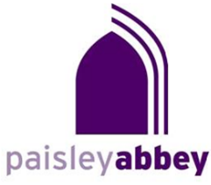

Saturday Lunch Hour Concerts

Concerts at 12.30 pm
Admission is £5 payable at the door

24 February
Peter Seivewright (piano)
Music by Khachaturian and Balakirev

23 March
Scottish Clarinet Choir

20 April
Abbey Strings

1 June
Douglas Lawrence (violin)
Maureen Rutherford (piano)

15 June
Richard Craig (flute)
Classical and contemporary chamber works for flute

Paisley Abbey (Church of Scotland) – Registered Charity No. SC007633

