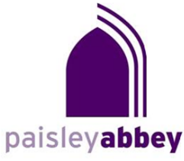

Sunday Organ Recitals at 3 pm
Admission is £10 payable at the door

In celebration of the Cavaillé Coll Organ 1874-2024

7 April
George McPhee
Director of Music at Paisley Abbey

21 April
John Kitchen
Organist to Edinburgh City, Edinburgh University
& Old St. Paul’s Church

28 April
Tiffany Vong
Jordanhill Parish Church, Glasgow

19 May
James Lancelot
Durham Cathedral (Emeritus)

2 June
Mark Browne
Paisley Abbey

23 June
Matthew Beetschen
Dunfermline Abbey

30 June
Kevin Duggan
Dunblane Cathedral

Paisley Abbey (Church of Scotland) – Registered Charity No. SC007633

